**Process Build Step 1 – Validate Pre-requisite**

* Delivery Methodology Pre- Req (PDD, SDD, PDI)
* Environment Pre-Req (Dev Env, BP installed, Test Data)
* People Pre-Req (SME, IT – connectivity issue/network fault)

**Process Build Step 2 – Process Template**

* Time, Standards, Consistency

**Process Build Step 3 - Implementing PDI**

* Process main page (high level flow diagram) and sub pages (start, stop, populate work queue)
* Adding control using Stop Decision after each work item (Stop After Time/Items/ASAP – isStopReq()) from control room

**Robustness**

* Exception block in subpages with retry logic(one off network errors)
* Exception block in main page around subpage which interface with system, so that process is not terminated, o/p must be either Mark Item as Exception/Completed
* Mark Item As Completed subpage which terminates process if same exception occurs consecutively thrice (application change)

1)

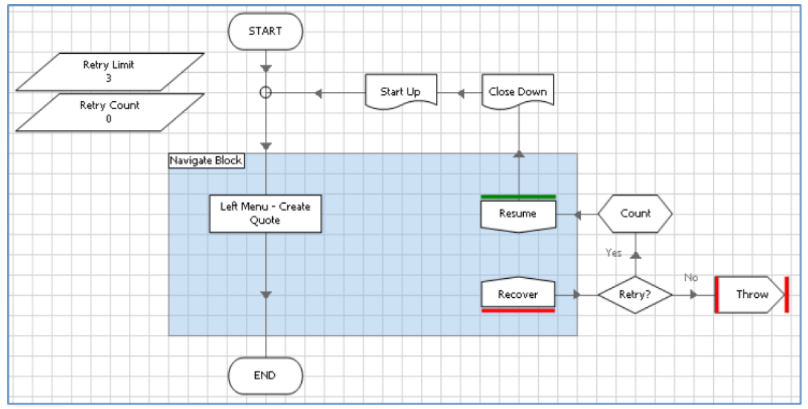

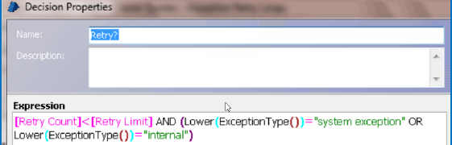

2)

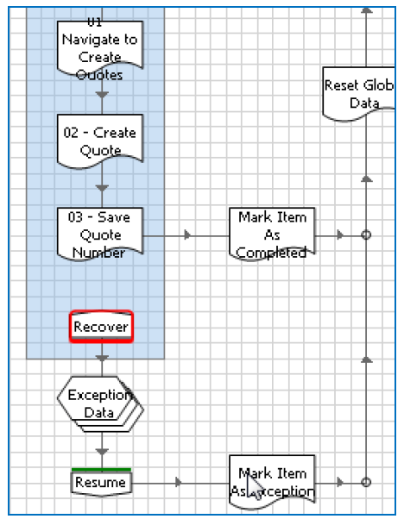

3)

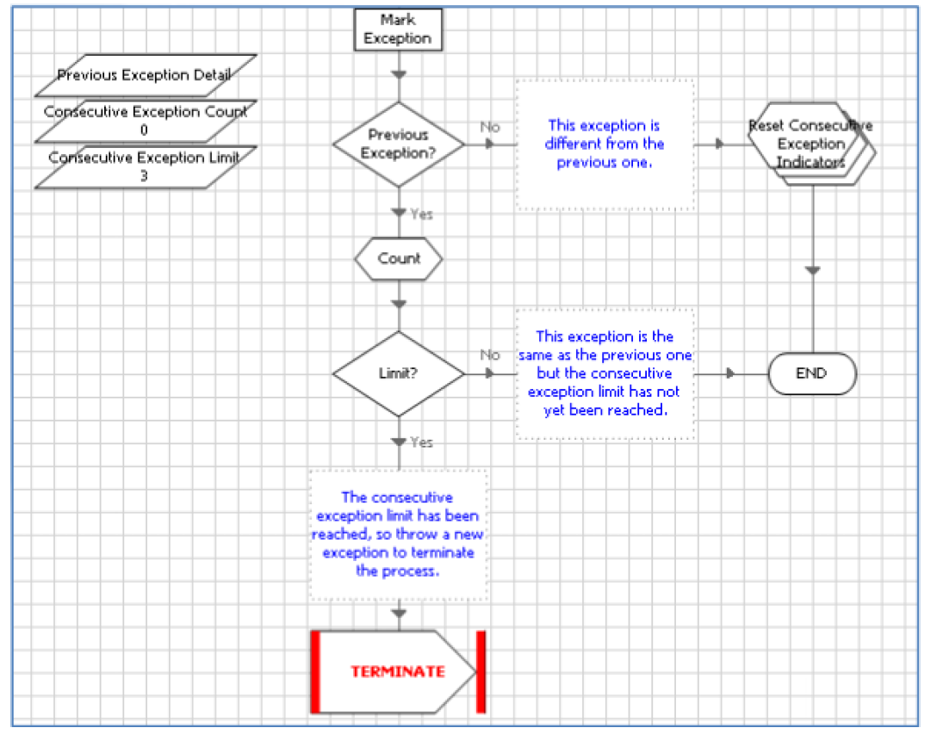

*Other Best Practices*

**1) Work Queue**

Always use queues even if single item/record to be worked as it helps in logging of time and exceptions

**Tags –**

* Easily search items in queue management using tags, also comes up in BP Performance report
* Helps identify total number of case types/ different work processed

**Status –**

* Identify status of progress of item which is currently worked upon
* Reworking an item that has thrown exception using forces retry – status could be used to skip the process flow that has already been completed for that item
* If the case has to be worked manually after exception, same above benefits

**2) Environment Variables**

* Website URL
* Network paths
* Email, database, web service configuration

**3) Credentials**

* Secure and encrypted store - BP credentials

**4) Process Alerts**

Ideally process execution should not be constantly monitored from control room instead Alerts could be built into process to inform controller team if something went wrong

Can be as simple as sending an alert when application terminates

* BP Process Alerts - System > Users > Configure >Process Alerts -- on BP machine
* Emails to controller team.
* Raise support ticket in existing workflow systems/crm from within process
* Use other monitoring tools to send alerts

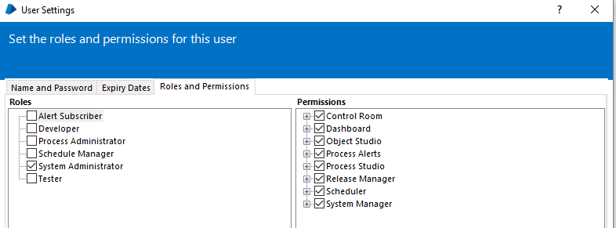

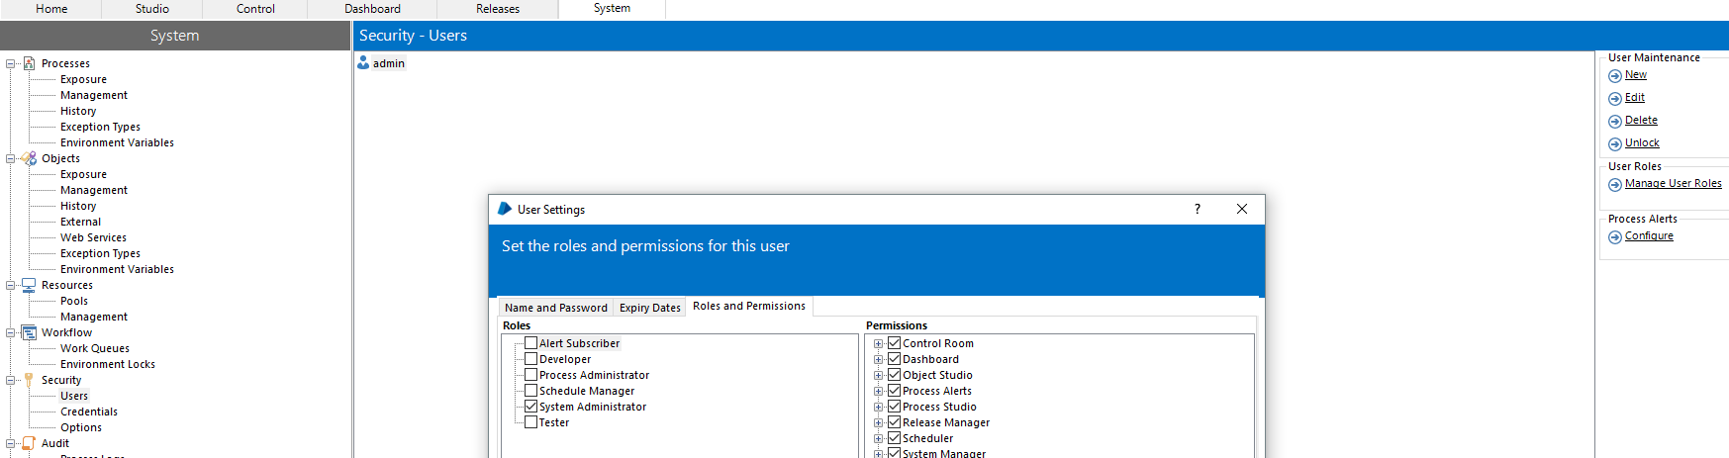

Only published processes appear on the list -

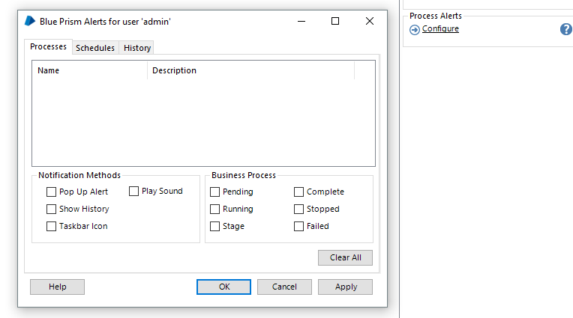

**5) System unavailable exceptions –**

Ideally in Mark as Exception sub page, if system is unavailable, then instead of terminating, it must send alert to controller team and periodically try to restart the system in error.

Polling logic must use stop decision to check if controller has requested process should stop or stop after certain time/attempts

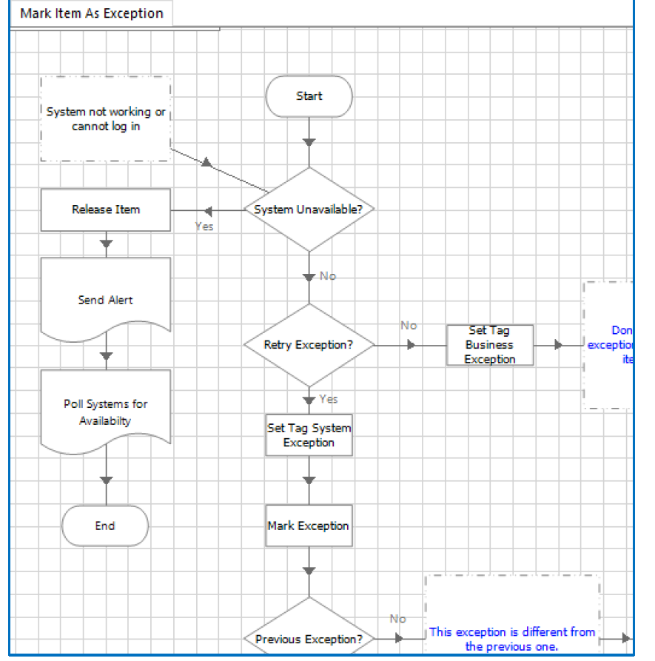

**Process Build Step 4 - Test as you build**

Run at full speed even if you have only start up and close down pages

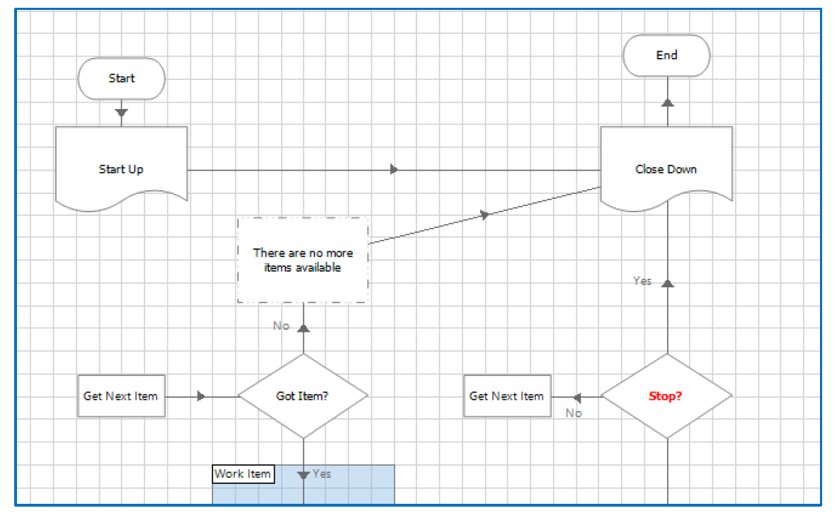

**Process Build Step 5 – Peer Review**

Process **MUST** be peer reviewed by experienced BP developer/mentor, not to undermine ability as we all may miss something and there can be a mentoring approach for new devs.

Ensure organization best practiced and BP conventions are followed (naming convention, alerting methods, security policies)

* Development Best Practice Guide
* Review Checklist

**Process Build Step 6 – SME Validation**

One of the benefits of Process Flow diagram is that it can be easily read by business users. Walk them through. Reduces risk of process being incomplete or incorrect

**Process Build Step 7 – Build readiness**

* *Turn off unnecessary logging* (System Tab > Audit > Process Logs)
* Only for stages that trace the route of the process. Keep on for choice and decision stages
* Turn off for stages that use customer data
* Turn off where it may generate large amounts of data – loops or stages with large input/output parameters
* *All docs up to date*

The Robotic Operation Model area of the portal includes the following templates:

* Blue Prism **Release Note Template** – a sign off document to ensure the agreed methodology has been followed and permissions given for your completed solution.
* **Operational Handbook Template** – this is a handover document from the developer to the Controller team that is going to be running and managing the process in production.